Position Description

Senior Lawyer – Conduct & Discipline

Business Unit Information
Business Unit Name: | NZ Conduct & Discipline
Reports to: | NZ Conduct Leader
Role Location: | The team is predominantly located in Wellington, however applicants from Auckland and Christchurch will be considered.

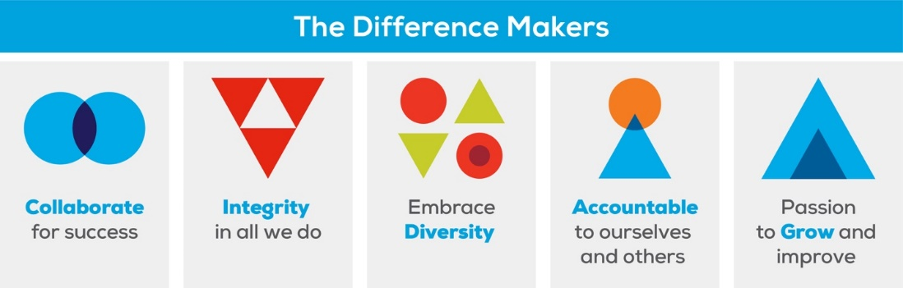
Chartered Accountants Australia & New Zealand Vision & Values

Business Description

We want you to help us by:
CA ANZ is a professional body representing 120,000 diverse, talented & financially astute members who skills make a difference for business the world over. CA ANZ aims to proactively shape the profession of the future by developing opportunities for our members that build value for themselves, their clients and the communities in which they live and work. We employ over 400 talented people in 14 locations in Australia, New Zealand, the UK and Asia. The NZ Conduct & Discipline team plays a vital part ensuring that the CA designation is held in high regard and the organisation meets its statutory responsibility to regulate the profession. We are a busy team of eight based in Wellington, Auckland and Christchurch, although our operations and hearings are predominantly in Wellington. Our team is multi-disciplinary with lawyers, CA and non-qualified staff. In managing the disciplinary function, we strive to operate a fair, efficient and robust process aligned with best practice for disciplinary jurisdictions.
- Investigating, analysing and managing a portfolio of complaints about Members of CA ANZ in New Zealand in accordance with the New Zealand Institute of Chartered Accountants (NZICA) Act, Rules, Code of Ethics and other governing standards and legislation
- Providing expertise, advice and information in relation to Professional Conduct activities to stakeholders including corresponding with a diverse range of participants involved in the complaints process
- Participating in the Secretariat function for the Professional Conduct Committee (PCC), including discussing/presenting cases to the PCC and assisting them with jurisdictional questions
- Having expertise in drafting a range of legal and other documents
- Managing complaints referred to the Disciplinary Tribunal for hearing and any appeals arising in conjunction with NZICA’s external legal counsel
- Assisting the NZ Conduct Lead with the supervision, mentoring and review of other team members’ work and other projects as required
- Acting as an ambassador for CA ANZ/NZICA, going above and beyond with our stakeholders and ensuring members and complainants receive with a professional and fair service at all times
- Assisting NZICA’s monitoring activities

We will give you responsibility for:
- Managing the investigation and processing of complaints and potential complaints allocated to you under a case management system, including liaising with parties, witnesses, experts, lawyers, the public, and other stakeholders
- Gathering relevant evidence and compiling agenda papers for consideration by the PCC
- Analysing evidence and drafting a range of key legal documents throughout the process
- Managing cases referred to the Disciplinary Tribunal for prosecution including drafting charges and evidence, working with witnesses, experts and the PCC’s prosecutor including any appeals arising
- Assisting the NZ Conduct Leader with the supervision, mentoring and review of other team members’ work
- Responding to enquiries and assisting with NZICA’s monitoring processes
- Undertaking project work or other duties as directed by NZ Conduct Leader

You will be successful if you:
- Are dedicated to meeting the expectations and requirements of internal and external stakeholders
- Look for improvements in processes where relevant
- Deliver work that is of a high standard with a precise attention to detail
- Have excellent research, writing and communication skills to ensure documents are prepared to a high standard and completed in agreed time frames
- Have good judgement, discretion and a professional approach
- Are collaborative and willing to assist other team members grow their expertise and capability
- Are able to travel periodically

We want you to bring and grow:
Skills & Experience
- Case management skills including proven investigative and multi-file management skills
- Prosecution or litigation experience and/or experience in other disciplinary, regulatory, or consumer protection regimes
- Understanding of range of legal fields/concepts and an ability to learn and apply new information quickly
- Knowledge of and attention to fundamental concepts such as due process, natural justice and public interest and professional obligations
- Ability to build and maintain effective business relationships with a diverse range of stakeholders
- Well-developed and effective oral and written communication skills
- Ability to manage stress and pressure well
- Discretion, empathy and courage to cope in an adversarial environment
- Proven conceptual, analytical and strategic thinking skills
- Proven ability to maintain a high level of confidentiality and professionalism
- Knowledge of accounting, auditing, tax, insolvency, financial services would be an advantage

Qualifications
- Bachelor of Laws with least 10 years relevant post admission experience
- Qualified Barrister and Solicitor of the High Court and ability to apply for a New Zealand practicing certificate

